Nama : Rizqi Surowati

Kelas : 5C

Nim : 18090072

**Source Code**

1. view-latihan2.php : application/views
2. Model1.php : application/models
3. Latihan1.php : application/controllers
4. Latihan2.php : application/controllers

**Url**

Latihan1.php:

<http://localhost/pustaka_booking_sr/index.php/latihan1/penjumlahan/4/5>

**Capture Hasil**

1. Latihan1.php

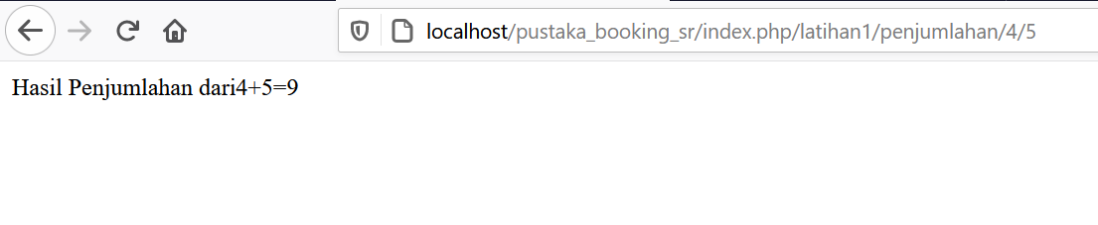

**Url**

Latihan2.php:

<http://localhost/pustaka_booking_sr/index.php/latihan2/penjumlahan/3/7>

**Capture Hasil**

1. Latihan2.php

